**J.P. Morgan Asset Management Project:**

**House Price Index Analysis**

IEOR E4721 (AI Applications in Finance) Final Report

Elisa Carucci ([ec3773@columbia.edu](mailto:ec3773@columbia.edu))

Yuelin Shen (ys3785@columbia.edu)

Zhuoyi Jiang ([zj2369@columbia.edu](mailto:zj2369@columbia.edu))

Princeton Huang (pjh2141@columbia.edu)

May 24, 2024

Supervised by

Prof. Ali Hirsa

Prof. Josh C. Panknin

Columbia University in the City of New York

Fu Foundation School of Engineering and Applied Science

**Table of Contents**

**1 Abstract 3**

**2 Review of Previous Work 5**

2.1 Fall 2021 5

2.2 Spring 2022 6

2.3 Summer 2022 7

2.4 Fall 2022 8

2.5 Spring 2023 9

2.6 Summer 2023 9

2.7 Fall 2023 10

[**3 Literature Review 11**](https://docs.google.com/document/u/1/d/18NTDaZbh9uB3ZtpxAVHUa4a9x5Fcw7yABfhLa2F7Py4/edit)

**4 Dataset and Data Techniques 13**

4.1 FRED Data and National HPI 13

4.2 Alternative Data 17

4.3 Data Analysis Techniques 18

**5 Methodology 22**

5.1 GRU Modeling 22

5.2 ACRNN (Adaptive Convolutional Recurrent Neural Network) 28

**6 Results and Discussion** **31**

6.1 Model Analysis 31

6.2 Feature Analysis and Regime Detection 33

**7 Conclusion** **40**

7.1 Project Summary 40

7.2 Future Work 42

**8 References** **43**

# **1 Abstract**

This comprehensive report integrates learnings from prior literature with empirical analysis to deepen the understanding of the Housing Price Index (HPI) dynamics in various urban contexts. As part of a broader, multi-semester project aimed at developing an accurate predictive model for HPI, with a special emphasis on forecasting recessions for investment purposes, the study focuses on four cities: Dallas, Denver, Miami, and San Diego. Exploring microeconomic elements that influence HPI, drawing insights from significant works such as "House of Debt" by Atif Mian and Amir Sufi, and delving into the Housing Price-Income ratio—as well as the Fragility Index—help to establish a solid foundational understanding of regional real estate trends.

Crucial factors examined comprise new home construction, existing supply, housing price-rent ratio, and the impact of geographic and political constraints on housing supply and prices. The report also analyzes building permits data to discern trends in housing developments and their correlation with HPI. Utilizing the Federal Reserve Economic Data (FRED) API, the study accesses vital metrics, including mortgage rates, credit availability, corporate debt outstanding, Median Household Income (MHI). It even incorporates industry-level indices, representing the luxury and automobile sectors.

A pivotal part of our contribution involves advancing the model's framework using a Gated Recurrent Unit (GRU) to predict HPI. This process involves data series smoothing and data augmentation, then introduction of a 1-Layer GRU with random search to decide the activation function and learning rate. The study meticulously examines the effectiveness of various variables and their combinations in predicting HPI, highlighting the challenges of overfitting and emphasizing the need for model refinement.

Initial findings demonstrate the importance of integrating lagging and regime-switching mechanisms into the GRU model to enhance its predictive accuracy for HPI. Regimes were generated with the R2-RD technique and were used not only as a predictor in each city-level dataset, but also for the subsequent analysis aimed at getting the best predictors for each model.

Specifically, the model demonstrates significant variability in performance across different cities. This suggests that the model may require adjustments to better account for local factors and market dynamics unique to each. The variability in the effectiveness of individual and combined variables across cities underscores the complexity of the housing market and the need for tailored predictive models.

The report provides valuable insights surrounding the factors that influence housing markets in different urban settings. It also suggests directions for future research, including the development of a Fragility Index, along with the exploration of additional economic factors and anomalies. This holistic approach enhances the understanding of HPI dynamics and aids in the development of nuanced predictive models for real estate markets, contributing significantly to urban economic modeling.

# **2 Review of Previous Work**

## **2.1 Fall 2021**

This semester marked the genesis of Columbia students’ collaborative effort with JP Morgan to analyze housing prices. The group endeavored to reliably predict House Price Index (HPI) at both the national and municipal levels. Taking into account each region’s respective geographies, cultures, policies, and stages of economic development, the following features were assessed:

| **Categories** | **Factors** |
| --- | --- |
| National macroeconomic variables | * Interest rate * Mortgage rate * Inflation rate * GDP level * Poverty rate * Gini coefficient * Unemployment rate * Job growth rate |
|
| Demographic variables | * Age and sex * Class of worker * Crime rate * Educational attainment * Geographical mobility * Personal and household income |
| Housing-Related Variables | * House price index * Median house sale price * Median sales per square root * Building permits * New privately-owned housing units started * Housing affordability index |

On the subject of modeling, the students adopted basic and standard analytical methods to gain a broad understanding of the whole dataset. In addition to PCA and linear regression, LSTM was also applied as a deep learning model to different time horizons and distinct features.

## **2.2 Spring 2022**

Building off of the initial project, the subsequent group of students developed a comprehensive machine learning-supervised model, with the intent of utilizing more sophisticated feature engineering to forecast future trends in HPI. Instead of simply integrating all possible features into models, they decided to take a step back and focus on data preprocessing. In other words, they aimed to achieve better results by improving the quality of inputs.

This group considered the following methods:

* Dropping highly-correlated features
* Normalizing data and adjusting it for inflation
* Standardizing data frequency between annual, quarterly, monthly, and weekly sources
* Interpolating via the cubic spline, stochastic regression, and Brownian bridge
* Generating new features

They selected relevant features after determining feature importance via SelectKBest with correlation statistics, p-value measurement using OLS, Random Forest, and XGBoost Importance Rank. With a well-prepared dataset in hand, the group then applied various classic machine learning techniques—comprising OLS, Lasso Regression, Ridge Regression, Random Forest, XGBoost and LSTM—to make predictions on the most important features. From their trials, they found the mortgage rate to be the most critical factor for all attempted methods, providing us with the intuition to dive even further into this particular element.

## **2.3 Summer 2022**

Following the progress made in the Spring 2022 cohort, the Summer 2022 cohort dove deeper into more specific factors. More concretely, they attempted to identify the markets with the highest dynamic growth potential, over a period of five to ten years. By utilizing quarterly data with its genesis in the 1980s, they investigated the possible relationships between HPI, Consumer Price Index (CPI), the Housing Affordability Index (HAI), and stratified/qualifying income ratio. All of these observations were made within the United States market. Notably, this group sought to eliminate the effects of inflation on their predictions.

| **Objective** | Monthly/Quarterly House Price Index (HPI), inflation-adjusted |
| --- | --- |
| **Factors** | * Total debt, inflation-adjusted * Inflation difference between HPI inflation and total debt inflation * Total consumer credit, inflation-adjusted * Stratified income * Comparing average/median home sale price sold to income ratio * Housing Affordability Index (HAI) |
| **Feature Engineering** | * Seasonal decomposition * Interpolation with Brownian bridge |

## **2.4 Fall 2022**

In Fall 2022, the students zeroed in on affordability and credit availability, in hopes of better understanding how exactly housing bubbles work. They further decomposed affordability into purchase and repayment components, thereby demonstrating the multifaceted relationship between housing price, interest rate, and income.

Taken into account with expectation theory, this group established how psychological factors play into how bubbles as a theoretical phenomena expand, then subsequently burst. They analyzed trends in both housing prices and bubbles themselves, developing a framework that makes use of three primary approaches: affordability and credit ability, expectation theory, and the residual income perspective.

| **Objectives** | Decomposing affordability in order to predict the next housing bubble |
| --- | --- |
| **Factors** | * Affordability Limit (AL) * HPI * Affordability at Risk (AaR) * Credit Availability * Housing Affordability Index (HAI) |
| **Feature Engineering** | * K-means Clustering * Adaptive Expectation |

## **2.5 Spring 2023**

By the time Spring 2023 rolled around, the students leveraged computational and analytical modeling, in order to develop a robust quantitative predictor for the trajectory and amplitude of HPI. They stressed the importance of regime detection, engaging in manual delineation, while also employing Bayesian Structural Time Series (BSTS) and Hidden Markov Models.

## **2.6 Summer 2023**

Come Summer 2023, the students were able to consider the relationships between affordability metrics and HPI in different cities, each of which was subject to unique price volatilities. Their development of HAI took into account both purchase and repayment affordability, reusing a formula previously set forth.

| **Formula: $PMT=HPI*scalar*(1-β)*\frac{i}{(1-{(1+i)}^{-N})}$ $QINC=PMT*4*12$ $HAI=\frac{MHI}{QINC}$** | | Where *i* = monthly mortgage rate,  *N* = remaining payment periods (i.e. 360),  and $β$ = down payments ratio. |
| --- | --- | --- |

The team divided their datasets based on geographical region, market size, population density, and political affiliations. The primary focus of their analysis was on contrasting trends between metropolitan areas. They observed that house price trends often differ between large and small cities, as well as between geographically-constrained regions. Similarly, high-density cities typically exhibit unique house price movements when compared to low-density counterparts, primarily due to variations in land availability and housing demand.

They also assessed the impact of housing recessions, analyzing the peak-to-trough decline which defined the 2009 recession, and how it set a historical precedent for affordability indexes within markets. The group was able to discover that credit availability was positively correlated with HPI, while interest rate fluctuations and moderate housing price increases did little to rock the stability of the Purchase Affordability Index (PAI). Similarly, a consistent PAI in non-metropolitan areas—despite rising house prices and declining interest rates—evidences discrepancies in pricing and responsiveness between environments.

## **2.7 Fall 2023**

Most recently, in Fall 2023, the students aimed once again to anticipate the general trajectory of HPI between cities. Using FRED to gather data on HPI, 3/10-year treasury rates, HAI, and Moody BAA rates, they were able to generate a prediction. However, their model significantly underestimated relative to actual values, particularly during the Great Recession. They also divided HPI into distinct regimes for further analysis, but were unable to predict said regimes sufficiently in the face of overall HPI direction and magnitude. Our work starts from were they left off as we improved the prediction of the HPI for each city.

# **3 Literature Review**

In this section, we list a summary of the literature focusing on housing affordability predictions and how macroeconomic factors affect the real estate sector.

| **L1** *Measuring housing affordability: Looking beyond the median (Gan & Hill, 2009)*   * Purchase Affordability: whether a household can borrow enough funds to purchase a house. * Repayment Affordability: consider the burden imposed on a household of repaying the mortgage. * Income Affordability: measure the ratio of house prices to income. * Credit impact: higher credit availability can worsen housing affordability. |
| --- |
| **L2** *Indicators of Local Housing Affordability (Bogdon & Can, 1997)*   * Spatial distribution of affordability. * Mismatch: separates the income into several groups and housing supplies. |
| **L3** *A new measure of housing affordability: Estimates and analytical results (Kutty, 2005)*   * Housing-induced poverty: the situation where a household, after paying for housing, cannot afford the poverty basket of non-housing goods. * Mismatch: separates the income into several groups and housing supplies. |
| **L4** *What is housing affordability? The case for the residual income approach (Stone, 2006)*   * Residual income: the selection of a normative standard for non-housing items and the treatment of taxes. |
| **L5** *Semi-structural credit gap estimation (Lang & Welz, 2018)*   * Theory-based Model * Proposed four factors that drive credit excess:   + real potential GDP,   + equilibrium real interest rate,   + population share of the middle-aged cohort,   + level of institutional quality. |
| **L6** *Credit availability and investment Lessons from the “great recession” (Gaiotti, 2013)*   * The impact of credit availability on economic activities: Larger when the economy is in contraction and not so much when the economy is expanding. |
| **L7** *Credit Availability and the Structure of the Homebuilding Industry (Ambrose & Peek, 2008)*   * Supplier-side credit impact in the real estate industry: Credit availability impacts more private home builders than public home builders. |
| **L8** *Credit Scoring and Mortgage Securitization: Implications for Mortgage Rates and Credit Availability (Heuson, Passmore & Sparks, 2001)*   * Securitizations lower the mortgage rate and improve credit access if the demand for credit is low. |
| **L9** *House of Debt (Mian & Sufi, 2014)*   * Great depression as a precedent: societal normalization of buying on credit * Impact of the 2008 recession: devastated entire local economies and led to heavy unemployment * Fatalistic perspective: large drop in economic activity cannot be predicted or avoided * Banking perspective: save the banks, save the economy * Optimists: willing to pay more for housing, and will do so with access to debt financing, thereby driving up the overall market price for housing * Pessimist: resolute to the idea that the true market value of housing is lower, lending to the optimists; belief that they will recover their investment after the bubble bursts |

# **4 Dataset and Data Techniques**

## [**4.1 FRED Data and National HPI**](https://colab.research.google.com/drive/1tjKLaXuvwiV9KskucPhMXeJ1yViKd1cG?authuser=1#scrollTo=uC9yET6wMW-l)

Based on the literature review, several variables especially conducive to HPI prediction became evident. The data for these originated primarily from the Federal Reserve Economic Data (FRED) database. Maintained by the Federal Reserve Bank of St. Louis, FRED is a comprehensive economic data source tracking a wide range of analytical and forecasting factors. The following section outlines the data retrieval process from FRED within the national and regional domains. It also provides an overview of each predictor used in the project model, along with their relevance and correlation to HPI.

The process began by selecting a series of key metrics correlated with the national HPI, for which demonstrations and specific relevance are detailed below.

###### **Mortgage Rate** - FRED Key: MORTGAGE30US

The mortgage rate, specifically the 30-year fixed mortgage rate, is a critical factor in the housing market. Lower mortgage rates reduce borrowing costs, rendering homes more affordable and stimulating demand, thereby driving up house prices. Conversely, higher mortgage rates can dampen demand and slow down price increases.

###### **GDP (Gross Domestic Product)** - FRED Key: GDP

GDP is a broad measure of economic health, representing the total economic output of a country. A growing GDP indicates a strong economy, which typically correlates with higher consumer confidence and increased demand for housing. As the economy expands, people are more likely to invest in real estate, leading to a rise in HPI.

###### **CPI (Consumer Price Index)** - FRED Key: CPIAUCSL

CPI acts as an overall measure of inflation, by tracking changes in the price level throughout a basket of consumer goods and services. Inflation impacts the purchasing power of consumers, reducing just how much can be purchased with the same nominal dollar amount on hand. In the context of real estate, rising inflation can lead to higher property values, as the costs of construction materials and labor increase.

###### **10-Year Treasury Yield Difference** - FRED Key: T10Y2Y

The 10-year treasury yield is a benchmark interest rate that influences mortgage rates and other long-term interest rates. It reflects investor sentiment and economic outlook. Lower yields generally lead to lower mortgage rates, boosting housing affordability and demand.

###### **Corporate Debt** - FRED Key: GFDEBTN

Corporate debt levels, represented by corporate bond yields, shed light on the financial health of companies. High levels of corporate debt can signal economic stress, potentially affecting employment and income levels. This, in turn, influences housing demand and prices.

###### **Unemployment Rate** - FRED Key: UNRATE

The unemployment rate is a key indicator of labor market health. Higher unemployment can reduce household income and consumer confidence, leading to lower demand for housing. Conversely, low unemployment suggests a strong job market, supporting people's ability to purchase homes.

###### **Credit Availability Index** - FRED Key: BOGZ1FA673065500Q

This index measures the ease with which consumers can obtain credit. Easier access to credit facilitates home purchases, supporting higher demand and potentially increasing HPI. Conversely, tighter credit conditions can constrain home buying activity.

###### **Business Confidence Index** - FRED Key: BSCICP03USM665S

This index reflects business leaders’ sentiment concerning the economic outlook. Higher business confidence can lead to increased investment and employment, boosting economic activity and housing demand.

###### **Used Auto Price Index** - FRED Key: MRTSSM44112USN

The used auto price index tracks changes in the prices of used cars. While not directly related to housing, it serves as a proxy for consumer spending behavior and inflationary pressures in the broader economy.

###### **Retail Auto Sales** - FRED Key: DAUTOSAAR

Retail auto sales indicate consumer spending on durable goods. High sales figures suggest strong consumer confidence and bolstered disposable income, which can translate into higher demand for housing.

###### **Luxury Goods Sales** - FRED Key: PCU721110721110103

The luxury goods sales index measures spending on high-end products. This indicator reflects the economic well-being of affluent consumers, who are often significant players in the real estate market—especially when it comes to high-end properties.

Each of these indicators provides valuable insights into different aspects of the economy that influence the housing market. By including these diverse predictors in our model, we aim to capture the multifaceted nature of the factors driving house prices. Economic health, consumer confidence, credit conditions, and inflationary pressures all play crucial roles in shaping housing demand and HPI.

## **4.2 Alternative Data**

## **Regime Detection**

Changes in economic activities can also affect the value of HPI. Therefore, in order to better capture the precise fluctuations under specific business cycles, we classify national HPI data into distinct economic regimes, and incorporate the indices as an additional feature in our input data. This classification helps qualify different market conditions and their transitions over time.

We employ a Markov Chain approach to model these transitions and simulate historical regimes, in addition to what was previously made available with the R2-RD method. In the regime detection process, we load the historical regime data, build a transition matrix that captures the probabilities of moving from one regime to another, and then simulate historical regimes.

We start from a known state to get regimes back in time. With the classified regimes of national HPI data and simulated historical data, we gain insights into the dynamics of the housing market over an extended period, along with the different phases of market conditions and their transitions. All of this information is crucial for accurate forecasting and analysis. The combined dataset subsequently provides a comprehensive view of historical and current economic regimes, enhancing the robustness of our predictive models.

## **Permits**

We also evaluate building permits for single-family homes. This metric quantifies approvals granted by local authorities for the construction of new single-family homes, which are significant as they reflect the eagerness of builders to invest in new construction. Permits mitigate market-based lags by preemptively providing insights into the future supply of housing in the market. Therefore, they represent a data source which not only influences housing prices and availability, but can even provide insight into the direction of the market in the near future. The dataset that we use incorporates monthly data, spanning from 2001 to 2023.

Building permits for multi-family homes are issued for the construction of residential complexes, such as apartments and condominiums. Like those for single-family homes, these permits are integral to understanding urban development and housing density trends. In the case of multi-unit dwellings, however, they indicate shifts towards more dense living arrangements. They can thus signal changes in urban planning and residential preferences. This dataset also covers monthly data from 2001 to 2023.

## **4.3 Data Analysis Techniques**

## **Smoothing**

In the context of time series forecasting, especially for HPI, data smoothing is an absolute necessity. This is because it helps to mitigate noise and make the underlying trends more discernible. In our project, we apply Brownian Bridge interpolation to achieve a more refined and continuous dataset.

The Brownian Bridge statistical technique interpolates values between two data points in a time series. This method generates a smooth transition between known data points by simulating the random walk properties of a Brownian motion, which ensures that interpolated values follow a realistic path constrained by the end points. This approach is particularly useful when dealing with economic time series data, where sudden jumps between data points are uncommon, and a more gradual transition is expected.

We define a ‘brownian_bridge’ function to recursively interpolate values between two points (x0, y0) and (x1, y1). It calculates the midpoint (xm) and generates a new interpolated value (ym), with a normal distribution centered between the y-values of the endpoints, and a standard deviation proportional to the distance between them. We then use another ‘bb_interpolation’ function to apply the Brownian Bridge interpolation to specific columns of the time series data, thereby achieving a more continuous and smoothed dataset.

This method helps to fill gaps between the existing data points, rendering the dataset more robust for predictive model training. The smoothed data better captures the underlying trends and reduces the influence of noise, leading to improved model accuracy and stability.

## **ARIMA-Based Data Augmentation for City Level HPI**

To ensure comprehensive and accurate HPI forecasting, it is crucial to have a complete dataset that incorporates historical values, even for periods where data might be missing. We employ the AutoRegressive Integrated Moving Average (ARIMA) model to backcast data points for city-level HPI, thereby augmenting our dataset. This section details the methodology and implementation of this process.

ARIMA is a powerful statistical technique widely used for time series analysis and forecasting. It combines autoregressive (AR) terms, differencing (I), and moving average (MA) terms to model temporal dependencies in the data. While ARIMA is typically used for forward forecasting, we utilize it to fill in data points backward in time—a practice which, although less common in nature, can provide valuable historical context for our predictive models.

| **ARIMA Model** | |
| --- | --- |
| **Parameters:**  *p*: The number of lag observations (autoregressive term). *d*: The number of times that the raw observations are differenced (differencing term) *q*: The size of the moving average window (moving average term) | |
| **Formula: $y_{t} =c +ϕ_{1}y_{t-1}+ϕ_{2}y_{t-2} + ... +ϕ_{p}y_{t-p}+θ_{1}ϵ_{t-1}+θ_{2}ϵ_{t-2}+ ... +θ_{q}ϵ_{t-q} +ϵ_{t}$**  where $y_{t}$ is the value at time t  *c* is a constant  ϕ are the autoregressive parameters  θ are the moving average parameters  Є is the error term at time t | |

## 

To illustrate the process where augmentation is necessary, we find the ACF and PACF functions for two time series from our ‘*get_data_final*’ code file. We began by fitting an ARIMA model to our existing dataset. To generate backward forecasts, we use the fitted ARIMA model’s prediction method, which allows us to specify a past date range for which we would like to generate estimates. By predicting values for a period before the start of our dataset, we are able to retrospectively fill in additional data points.

| **Identifying ARIMA orders for the time series dataset to apply synthetic augmentation:** | |
| --- | --- |

## 

We collect city-level HPI data using the FRED API, fit the ARIMA model to capture underlying patterns and trends, then generate and integrate backcasted values for the periods where data was missing. This, in turn, extends the dataset backward in time. We apply the above methodology to augment data for various cities, ensuring a comprehensive and robust dataset for each city's HPI. The process was repeated for multiple cities, including Dallas, Miami, San Diego, and Denver.

The application of ARIMA for backward data filling complements our Brownian Bridge interpolation efforts, resulting in a refined and enriched dataset. This approach underscores the importance of leveraging advanced time series techniques to handle gaps in historical data, ultimately contributing to the robustness and reliability of our HPI predictive models.

# **5 Methodology**

## Evidently, we have explored various modeling techniques to predict HPI using historical economic data. Nevertheless, the most important component is the model itself. After employing and comparing diverse methods, we aim to identify the most effective approach for HPI prediction. This will enhance our understanding of the economic factors that influence house prices, with the comparative analysis offering informed recommendations to the field of real estate market forecasting.

## **5.1 GRU Modeling**

We select the GRU method as a foundation for our model. Like LSTM, this represents a variant of RNN that is designed to capture dependencies in sequential data, albeit with a simpler architecture. GRUs often perform similarly to LSTMs, but with fewer parameters, making them more efficient and faster to train. In the case of modeling complex sequential patterns, the key advantage of GRU lies in its computational efficiency and reduced training time, especially when compared to LSTM. However, GRUs may not capture long-term dependencies as effectively as LSTMs in some scenarios. Furthermore, in spite of greater efficiency, GRUs still require significant computational resources to run. We detail our process below.

###### **Getting Started**

First, we load the historical economic data generated in section 4, and normalize it to ensure that all features contribute equally to the model training process. We perform the normalization using Min-Max scaling, which scales the data within a range of 0 to 1.

###### **Data Preparation**

Next, we prepare the data for the GRU model by creating input sequences (X), as well as corresponding target values (y). Each sequence consists of historical data points used to predict the next HPI value. This methodology involves setting a specific time window (n_steps), then sliding it over the data, in order to create overlapping sequences.

###### **Train-Test Split**

We split the data into training and testing sets to evaluate the model's performance, with a larger portion of the data used for the former, and a smaller portion reserved for the latter.

###### **Building and Training the Model**

The GRU model architecture is constructed using Keras. It comprises a GRU layer followed by a dense layer that outputs the predicted HPI value. The model is compiled with Mean Squared Error (MSE) as the loss function, and trained using the training dataset. Hyperparameters such as the number of GRU units, activation function, and learning rate are tuned using Random Search.

###### **Performance Evaluation**

Finally, we evaluate the model's performance on the test dataset using Mean Squared Error (MSE) as the evaluation metric, that of which is calculated from the predictions on the test set. MSE provides an indication of the model's accuracy in HPI forecasting, helping us compare its effectiveness against other models used in this project. Through this implementation, we aim to make accurate HPI predictions, by capturing the long-term dependencies in the historical data.

The aforementioned Random Search method systematically explores a predefined hyperparameter space to find the optimal configuration that minimizes the validation loss. This method aims to efficiently search through a wide range of hyperparameter values, thereby improving the model's performance without exhaustively trying every possible combination.

###### **Hyperparameters**

The range of each hyperparameter is defined by specifying the minimum and maximum. Moreover, it is also possible to designate the step size or distribution, from which values are sampled. Tuning candidates include the following hyperparameters:

* The number of GRU units
* Activation function
* Learning rate
* Regularization strength (if applicable)

We also iterate several lag values, applying HPI to find the ideal choice, in addition to testing the best lag value through a Granger causality test. In terms of breaking down the code:

* The *GRUHyperModel* class inherits from the HyperModel, providing a structure for building GRU models with tunable hyperparameters.
* Within this class, a method named ‘build’ is defined, which constructs the GRU model, using hyperparameters sampled by the Random Search algorithm.
* The Random Search algorithm, implemented through the ‘RandomSearch’ class from *keras_tuner*, iterates over a predefined number of trials.
* For each trial, a set of hyperparameters is randomly sampled from the specified ranges, and a corresponding GRU model is built and trained.
* The objective function—typically the validation loss—guides the search process, with the aim of minimizing this metric.
* The best-performing model, based on the chosen objective function, is selected at the end of the search process.

### **Model Refinement and Optimization**

As demonstrated above, by iterating over all possible combinations based on which regime we are in, we optimize our GRU model to identify the most crucial features and combinations for HPI prediction. We subsequently re-evaluate the model using the best predictors for each city, taking into consideration the most important ones for each regime, and thereby highlighting the top feature combinations with the highest impact on the model's performance.

By focusing on these optimal combinations, we can enhance the accuracy and robustness of our HPI predictions, providing valuable insights into the economic factors that drive house prices. The top three feature combinations identified through this process offer a targeted and efficient feature set that maximizes the model's predictive performance.

| **GRU Model Architecture:**   1. **Update Gate ($z_{t}$):** Determines how much of the past information needs to be passed along to the future 2. **Reset Gate ($r_{t}$):** Determines how much of the past information to forget | | |
| --- | --- | --- |
| **Update Gate: $z_{t} =σ(W_{z}⋅[h_{t-1},x_{t}]+b_{z})$**  **Reset Gate: $r_{t} =σ(W_{r}⋅[h_{t-1},x_{t}]+b_{r})$**  **Candidate Activation (new memory content): $\underline{h_{t}} = tanh(W_{h}⋅[r_{t}∘h_{t-1},x_{t}]+b_{h})$**  **Final Memory at Current Time Step (current hidden state): $h_{t} = (1-z_{t})∘h_{t-1}+{z_{t}∘\underline{h_{t}} }_{})$**  where σ is the sigmoid activation function   * tanh is the hyperbolic tangent activation function (element-wise multiplication) $W_{z}$* , $W_{r}$, and $W_{h}$ are weight matrices for the update gate, reset gate, and candidate activation, respectively $b_{z}$* , $b_{r}$, and $b_{h}$ are bias vectors for the update gate, reset gate, and candidate activation, respectively $h_{t-1}$* is the hidden state at the previous time step $x_{t}$* is the input at the current time step $h_{t}$* is the hidden state at the current time step | | |
| **Within-city results for each of the four cities evaluated:**  **Dallas**    **Denver**    **Miami** | | Criteria addressed include:   * All predictors * Augmented dataset * No lagged values |
| **San Diego** | | |

## **5.2 ACRNN (Adaptive Convolutional Recurrent Neural Network)**

ACRNN combines the strengths of Convolutional Neural Networks (CNN) and Recurrent Neural Networks (RNN). The CNN component primarily captures spatial patterns and hierarchical representations, while the RNN component captures temporal dependencies, rendering ACRNN particularly powerful for analyzing multivariate time series data.

The main advantage of ACRNN is its ability to model complex interactions between different features over time, often resulting in superior performance for intricate prediction tasks. However, ACRNN models are highly complex and computationally intensive, requiring substantial amounts of training data and careful tuning of both CNN and RNN components. This complexity can make ACRNN models challenging to implement and optimize, but their potential for high accuracy makes them a compelling choice for sophisticated time series forecasting.

### **Data Preprocessing**

Before feeding the data into the ACRNN model, we normalize the input features to have zero mean and unit variance. The goal of this is to ensure stable training. We then proceed by generating input sequences of fixed length from the historical time series data, of which each contains historical HPI, GDP, and housing permit values for multiple cities. Afterwards, we split the dataset into training and testing sets, as detailed in our description of the GRU model.

### **Model Architecture**

Convolutional layers form the baseline, and they help in learning hierarchical representations of the input data. This is crucial for identifying patterns across different cities, along with their impact on the HPI. Recurrent layers bolster this backbone by processing CNN layer outputs, enabling the model to learn the sequential patterns and relationships between different time steps. Tying everything together is the integration layer, which leverages concatenation to combine the spatial and temporal features learned by each component. Finally, the output layer passes integrated features through a fully connected layer, predicting future HPI values as a result.

### **Model Training and Evaluation**

The ACRNN model is trained by minimizing a loss function—such as Mean Squared Error (MSE)—using an optimization algorithm, like Adam or RMSProp. Early stopping and learning rate scheduling techniques help to prevent overfitting and ensure convergence during training.

Following the training process, we use the testing set to assess the model's performance, with performance metrics evaluating how well it predicts future HPI values. Additionally, we analyze the model's ability to capture long-term trends, short-term fluctuations, and the impact of different economic indicators on HPI. A summary of the complete timeline can be found below:

| **ACRNN Model Architecture:**  **Convolutional Layers** extract local features from the input data: $F_{t}=Conv(X_{t},W_{conv},b_{conv})$ where $X_{t}$ is the input at time step t $W_{conv}$  * and $b_{conv}$ are the weights and biases of the convolutional layer $F_{t}$* is the feature map obtained after applying the convolution operation   **Recurrent Layers** capture the temporal dependencies in the data.  **Attention Mechanism** focuses the model on the most relevant parts of the input sequence: $e_{t}=score(h_{t},H)$ $α_{t}=\frac{exp(e_{t})}{\sum_{k}{}exp(e_{k})}$ $c_{t}=\sum_{t}{}α_{t}h_{t}$ where ${ e}_{t}$ is the attention score, often computed using a compatibility function: $α_{t}$  * is the attention weight, obtained by applying a softmax function to the attention scores $c_{t}$* is the context vector, which is a weighted sum of the hidden states   **Final Output Layer** represents a fully connected (dense) layer, followed by a softmax or other activation function, depending on the task: $\hat{y}=OutputLayer(c_{t})$   where $\hat{y}$ is the predicted output: $c_{t}$  * is the previously established context vector | |
| --- | --- |

# **6 Results and Discussion**

## **6.1 Model Analysis**

After testing both the GRU and ACRNN approaches, we elect to proceed with the former, due to its enhanced performance. Meanwhile, the latter suffers from poor compatibility with the test set over an extended period of time, in spite of high initial accuracy.

**Prediction Performance of GRU Model**

The results from our GRU model demonstrate its effectiveness at capturing complex temporal patterns within HPI data. Nevertheless, we proceed to elevate our analysis by adding a *HPI_pct_change* column to each city dataset and normalizing the data, as well as deleting ‘null’ and ‘inf’ values. We also drop the regime column from each dataset, then perform the best lag detection using the Granger causality test to find lags for each feature, as shown below:

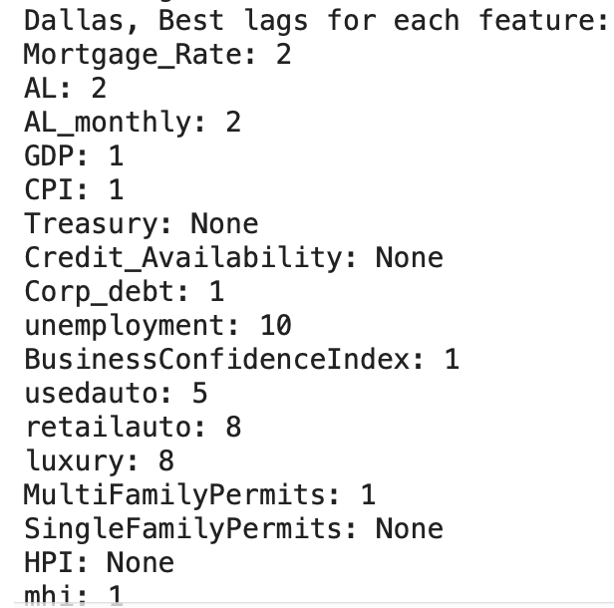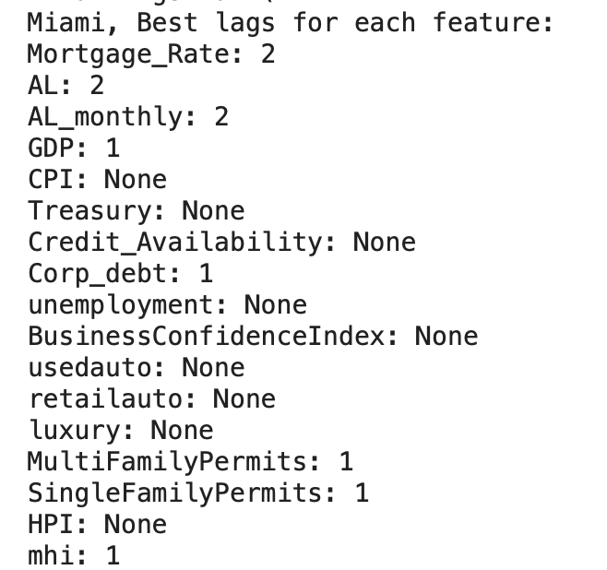

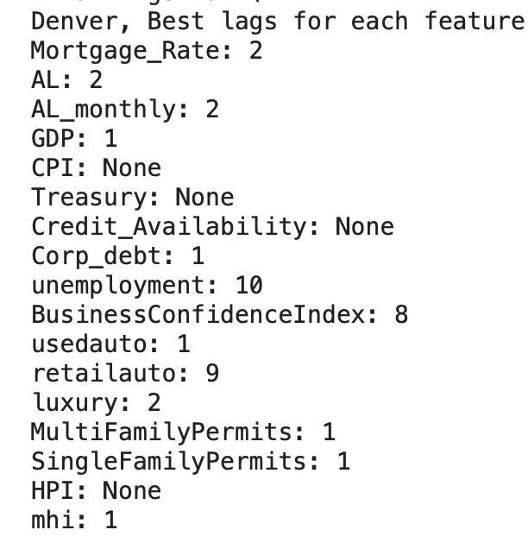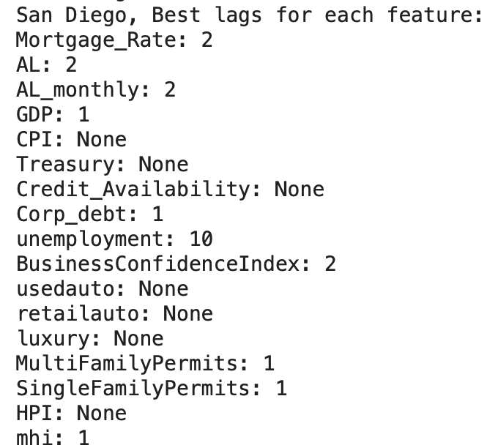

## **6.2 Feature Analysis and Regime Detection**

We then reorient our efforts towards finding highly correlated features for each of the four cities, using PCA, Ledoit-Wolf Shrinkage, and OAS to regularize the input dataset. PCA reduces the dimensionality of the dataset, in order to address multicollinearity, as well as improve computational efficiency. Meanwhile, Ledoit-Wolf Shrinkage helps ensure that the covariance matrix is positive definite and less sensitive to noise. Finally, OAS applies additional regularization by adding a small value to the diagonal elements of the covariance matrix, further ensuring its positive definiteness.

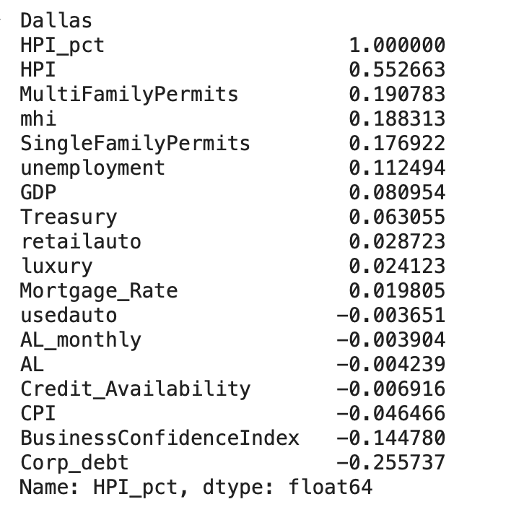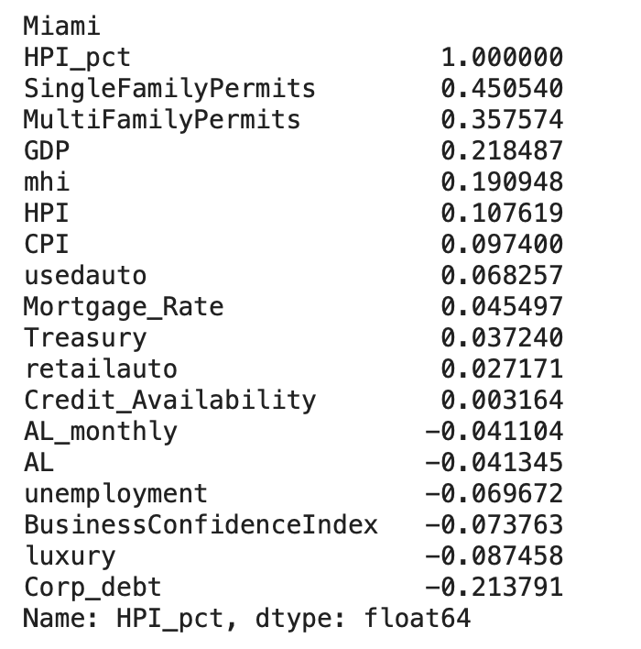

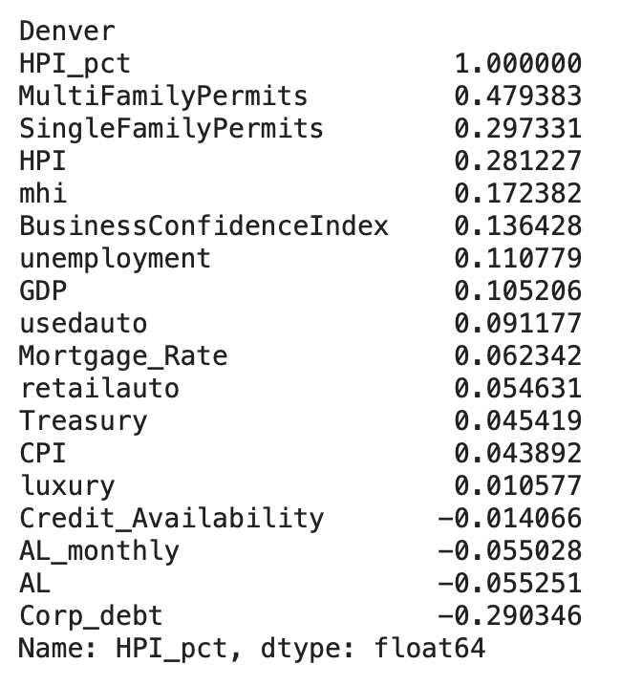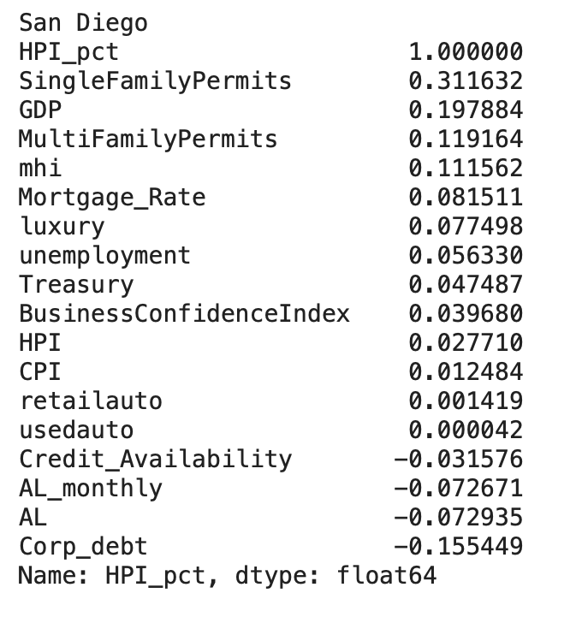

Next, we proceed with model fitting and regime detection. We run a decision tree regressor model to derive the importance score for each feature, in each regime, for each city. The correlation heatmaps are as follows:

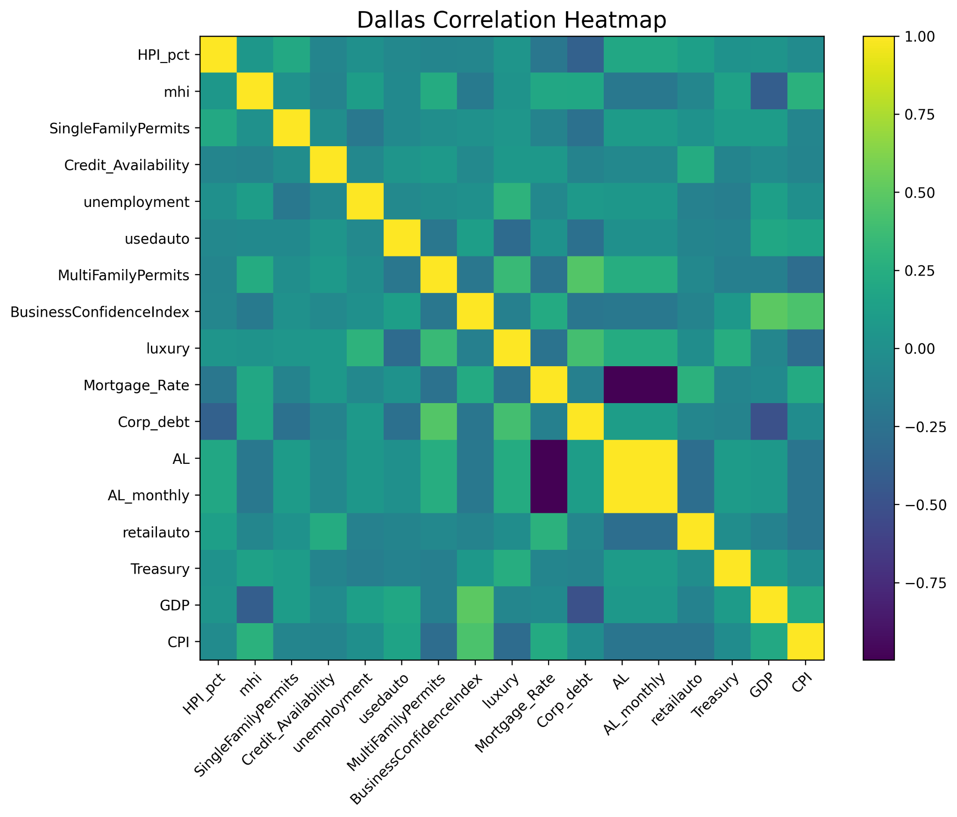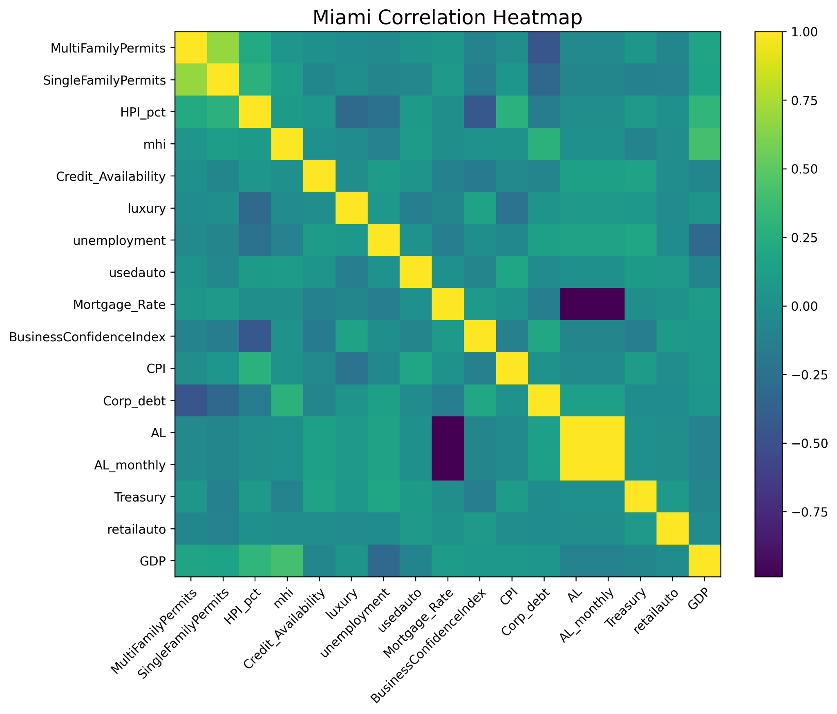

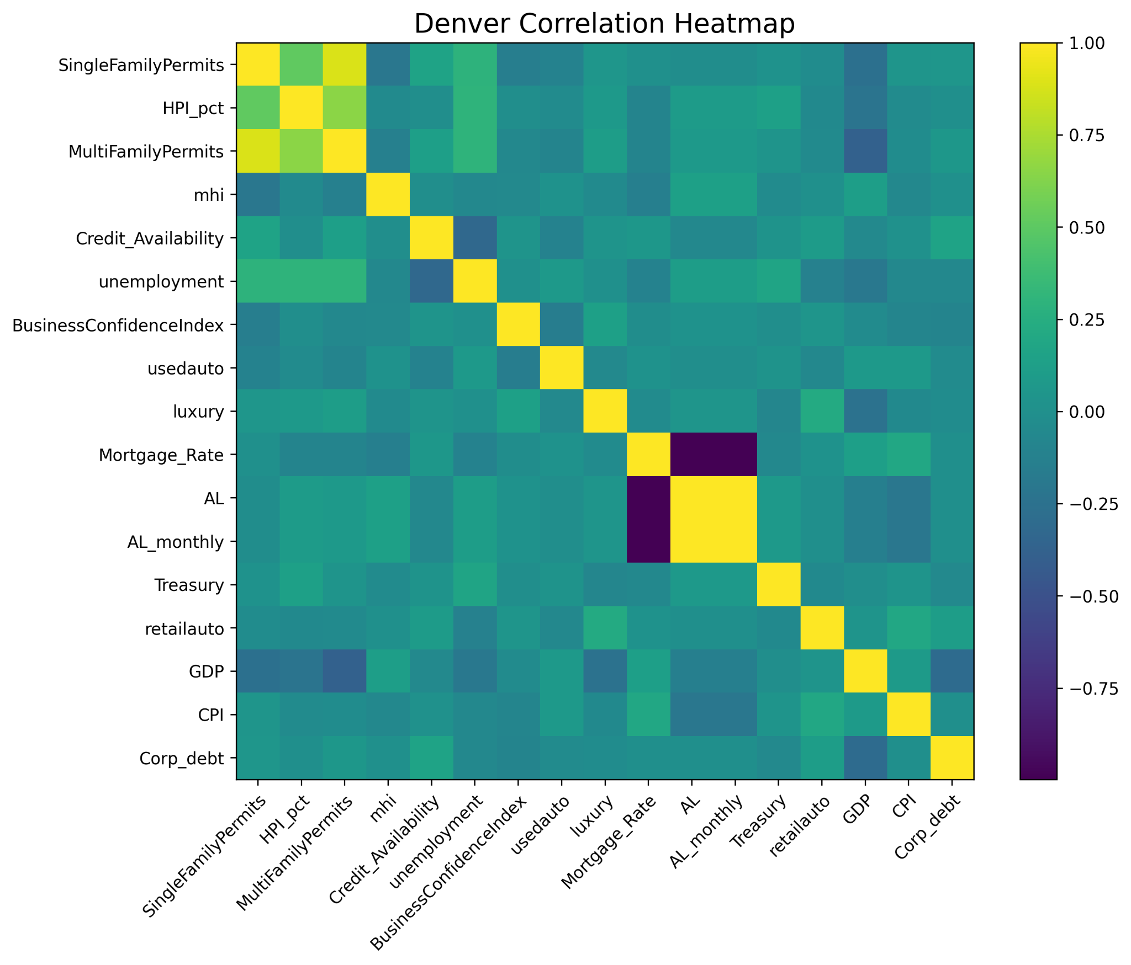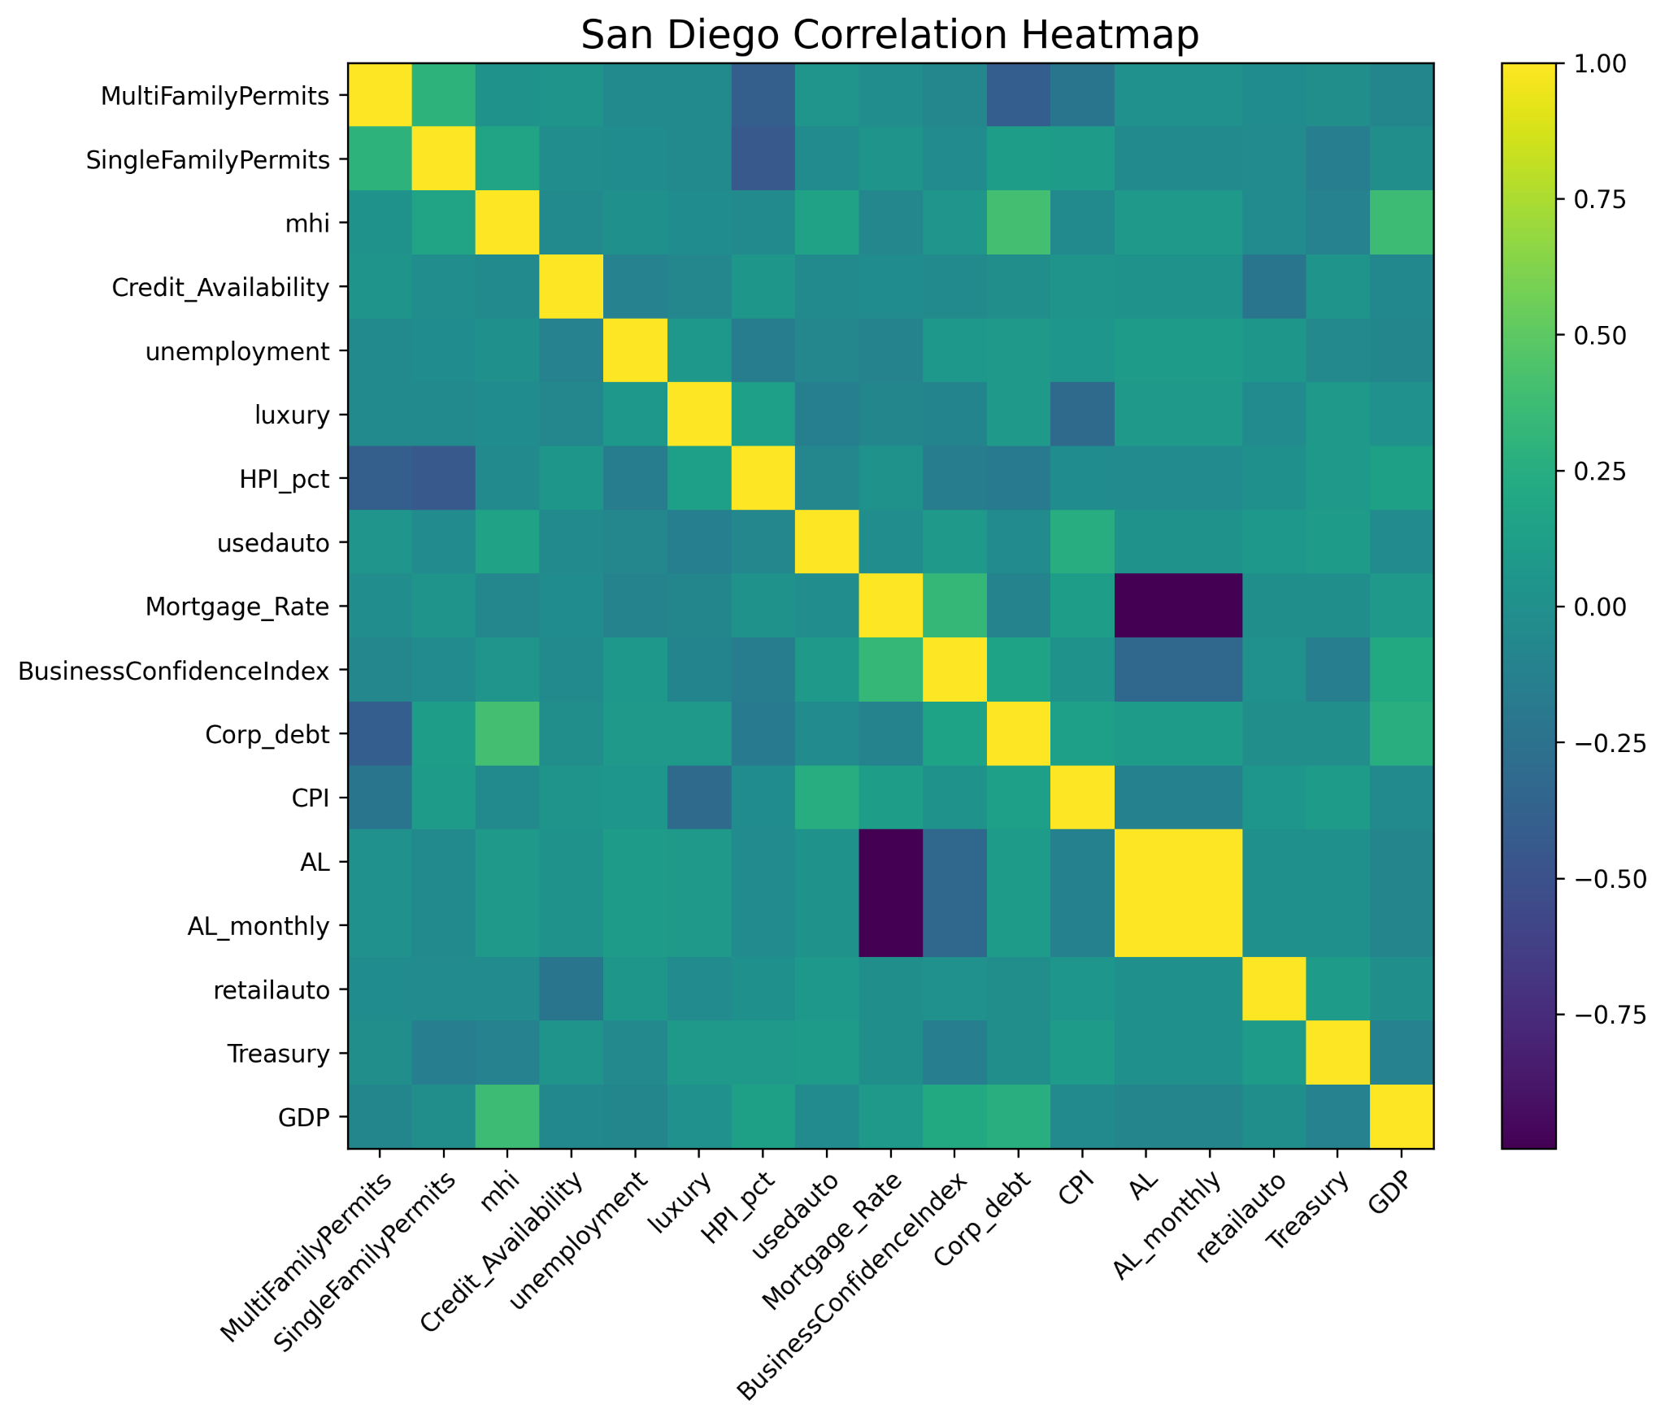

Consequently, using an HMM model, we classify each date in HPI with a specific regime. We also train a decision regression tree model on the entire dataset to find the feature importance score, whilst considering how each regime corresponds to each date. We then run the GRU again, selecting all features with an importance score over 0.2.

| **Predictors selected for Dallas: 'BusinessConfidenceIndex','Credit_Availability', 'GDP', 'Corp_debt', 'Treasury', 'mhi', 'HPI', 'MultiFamilyPermits'** | |
| --- | --- |
| **Regime #1** |  |
| **Regime #2** |  |
| **Regime #3** |  |
| **Regime #4** |  |

| **Predictors selected for Miami: 'BusinessConfidenceIndex', 'GDP', 'Corp_debt', 'unemployment', 'mhi', 'HPI', 'MultiFamilyPermits'** | |
| --- | --- |
| **Regime #1** |  |
| **Regime #2** |  |
| **Regime #3** |  |
| **Regime #4** |  |

| **Predictors selected for Denver: 'SingleFamilyPermits', 'Treasury', 'CPI', 'unemployment', 'mhi', 'HPI', 'MultiFamilyPermits', 'retail auto'** | |
| --- | --- |
| **Regime #1** |  |
| **Regime #2** |  |
| **Regime #3** |  |
| **Regime #4** |  |

| **Predictors selected for San Diego: 'SingleFamilyPermits', 'CPI', 'GDP', 'mhi', 'HPI', 'Credit_Availability'** | |
| --- | --- |
| **Regime #1** |  |
| **Regime #2** |  |
| **Regime #3** |  |
| **Regime #4** |  |

# Based on the search results for each city, we could then reselect the features that have a relatively high importance score, in order to train the model. It is clear that not every feature in the dataset has the same impact on model performance as others. By reselecting features with importance scores over 0.2, we reduce computational costs, while also yielding stronger prediction accuracy.

# Using only the selected predictors established above, the HPI prediction results for each city are displayed below. Key metrics to evaluate performance are the RMSE and R-squared value:

| **Dallas** | | Train RMSE: 3.1891  Test RMSE: 4.0339  Test R^2: 0.9927 |
| --- | --- | --- |
| **Denver** | | Train RMSE: 2.4122  Test RMSE: 5.0714  Test R^2: 0.9937 |
| **Miami** | | Train RMSE: 10.2503  Test RMSE: 5.3365  Test R^2: 0.9923 |
| **San Diego** | | Train RMSE: 8.4900  Test RMSE: 2.4027  Test R^2: 0.9979 |

# **7 Conclusion**

## **7.1 Project Summary**

In this project, we set out to predict the House Price Index (HPI), using a GRU model to capture its intrinsic temporal patterns. We use a combination of historical economic indicators and advanced time series modeling techniques to achieve this goal. In totality, our model is able to successfully mirror historical HPI trends, accurately forecasting patterns of growth and decline.

We also incorporate regime detection with HMM to accommodate varying economic conditions, enhancing our model’s robustness. The fact that the best predictors can change according to each city demonstrates the model’s maneuverability and predictive effectiveness. Furthermore, our approach is significantly more efficient. When previous groups chose to run a loop while training the model, they limited the number of inputs that they could analyze, along with the output of ideal combinations. In the same vein, the variances in their results could become almost imperceptible, negating the individuality of each regional context and how these differences could affect HPI.

**Feature Importance:**

Following an iterative feature selection process, we select the top three models for each city. We then optimize and retrain the modeling procedure based on features with high importance scores. When comparing performance between the initial dataset and the newly optimized dataset across all cities, the test RMSE decreases from 30 to 5. This suggests that, by selecting only the relevant features, we could significantly enhance the model’s performance.

**Comparative Analysis with ACRNN**

We begin our analytical work by exploring the potential of ACRNN (Attention-based Convolutional Recurrent Neural Network) for HPI prediction. Nevertheless, in spite of their sheer power, ACRNN methods are computationally intensive and complex. This means that they require significant amounts of training data, along with meticulous tuning. Consequently, the high complexity and resource demands of ACRNN models limit our ability to achieve satisfactory results. These observations underscore the necessity for future research to further explore ACRNN's capabilities, potentially leveraging larger datasets and more advanced computational resources.

## **7.2 Future Work**

Building upon our findings, future research would ideally focus on further refining GRU models and exploring ACRNN, particularly with more extensive datasets and computational resources. Additionally, integrating more granular economic indicators and exploring alternative machine learning techniques could enhance predictive accuracy, providing deeper insights into the motivating factors behind house prices.

# **8 References**

Ambrose, Brent & Peek, Joe. (2008). Credit Availability and the Structure of the Homebuilding

Industry. Real Estate Economics. 36. 659-692. 10.1111/j.1540-6229.2008.00226.x.

Bogdon, A.S. and Can, A. (1997), Indicators of Local Housing Affordability: Comparative and

Spatial Approaches. Real Estate Economics, 25: 43-80. <https://doi.org/10.1111/1540-6229.00707>

Gaiotti, Eugenio, (2013), Credit availability and investment: Lessons from the “great recession”,

European Economic Review, 59, issue C, p. 212-227, https://EconPapers.repec.org/RePEc:eee:eecrev:v:59:y:2013:i:c:p:212-227.

Gan, Quan & Hill, Robert. (2008). Measuring Housing Affordability: Looking Beyond the

Median. Journal of Housing Economics. 18. 115-125. 10.1016/j.jhe.2009.04.003.

Heuson, Andrea & Passmore, Wayne & Sparks, Roger, 2001. "[Credit Scoring and Mortgage](https://ideas.repec.org/a/kap/jrefec/v23y2001i3p337-63.html)

[Securitization: Implications for Mortgage Rates and Credit Availability](https://ideas.repec.org/a/kap/jrefec/v23y2001i3p337-63.html)," The Journal of Real Estate Finance and Economics, Springer, vol. 23(3), pages 337-363, November.

"House of Debt," University of Chicago Press Economics Books, University of Chicago Press,

number 9780226271651, September.

Kutty, Nandinee. (2005). A new measure of housing affordability: Estimates and analytical

results. Housing Policy Debate - HOUS POLICY DEBATE. 16. 113-142. 10.1080/10511482.2005.9521536.

Lang, Jan Hannes and Welz, Peter, Semi-Structural Credit Gap Estimation (November 13, 2018).

ECB Working Paper No. 2194, Available at SSRN: <https://ssrn.com/abstract=3284427> or [http://dx.doi.org/10.2139/ssrn.3284427](https://dx.doi.org/10.2139/ssrn.3284427)

Stone, Michael. (2006). What is Housing Affordability? The Case for the Residual Income

Approach. Housing Policy Debate - HOUS POLICY DEBATE. 17. 151-184. 10.1080/10511482.2006.9521564.